AIS-220 Event Data Recorder
Device & Configuration Application
User Manual
Release 2, July 2026

Changes Log
Description | Date | Release
First release of this manual. | July 2026 | 1
Added Section 11, Installation Instructions, covering the Full Connection Diagram (PC connection for data reading and configuration) and the Installation Connection Diagram (in-vehicle installation). | July 2026 | 2

Table Of Contents
1. Introduction
2. Getting Started - Connecting To The Device
3. CAN Engine Parameters
4. Global Settings
5. Device Logger
6. Storage Capacity - How Much Data Can Be Recorded
7. Trigger Types
8. Saving And Loading Device Settings To/From A File
9. Device Logger Files
10. Good To Know
11. Installation Instructions
11.1 Connecting To A PC - Full Connection Diagram
11.2 Vehicle Installation - Installation Connection Diagram

1. Introduction

1.1 What Is An Event Data Recorder (EDR)?
An Event Data Recorder (EDR) is a device fitted to a vehicle whose job is to record the vehicle's dynamic, time-series data (speed, braking, steering, safety-system activity, and similar signals) for a short window of time just before, during, and after a crash-related event. It works like a "black box".
The device continuously keeps the most recent readings from every configured parameter in a rolling (cyclic) buffer in memory - this happens constantly, at all times, whether or not an event is currently occurring. Older samples are automatically overwritten by newer ones as this buffer keeps rolling forward. This rolling buffer itself is not permanent storage - it only ever holds the last short window of readings.
The device is always watching for one of a small set of defined trigger conditions (see Section 7). The moment one of these triggers fires, the device copies the relevant portion of this rolling buffer - specifically, the window from 20 seconds before the trigger to 10 seconds after it - out of the cyclic buffer and into one of five protected, permanent Event slots. That data then survives, even through a crash, until it is deliberately read out and/or erased (see Section 5).
In short: the device is always recording into its short-term rolling buffer, but a moment of data only becomes a permanently-saved Event once a trigger condition actually copies it out of that buffer.

1.2 What Is AIS-220?
AIS-220 is an Automotive Industry Standard published in India, establishing uniform requirements for Event Data Recorders fitted to vehicles of categories M2, M3, N2, and N3 (larger passenger and goods vehicles). It is closely based on the international UN Regulation 169 (UN R169).
The standard defines exactly what data must be recorded, how many separate events must be stored, how long a window of time must be captured around each event, what triggers count as a recordable event, and how robust the recorder must be to survive a crash. This device and its configuration application are built to meet those requirements.

1.3 What This Device Does
The AIS-220 EDR device connects to the vehicle's CAN bus (the vehicle's internal communication network) and continuously listens to the specific signals the standard requires - vehicle speed, braking system status, steering angle, safety system activity, and more, as described in Section 1.1 above.
It is not possible to switch off or disable the Event Data Recorder function while the device is fitted to the vehicle - this is a deliberate requirement of the standard, not a limitation of this manual's instructions.

1.4 What The Configuration Application Does
The AIS220 Device Monitor is the Windows application used to set up and read back data from the device. Using this application, you can:
- Tell the device exactly where on the vehicle's CAN bus each required signal can be found, and how to decode it (the CAN Engine Parameters).
- Configure device-level behaviour such as reporting intervals and communication settings (the Global Settings).
- Read back the events the device has recorded (the Device Logger), inspect each one in detail, and export the data for further analysis.
- Save and reload your configuration to/from a file, so a known-good setup can be reused across multiple devices or backed up.
This manual walks through every part of the application, in the order you are most likely to need it.

1.5 A Few Terms Used Throughout This Manual
- CAN bus - the vehicle's internal wired network that carries messages between its various electronic control units (engine, brakes, steering, and so on).
- CAN message / Header ID - CAN data travels in short messages, each tagged with an identifying number (the Header ID). Multiple different signals are often packed into bytes of the same message.
- Trigger - one of the defined conditions (listed in Section 7) that causes the device to permanently save an event.
- Event / Slot - a single recorded incident, stored in one of the device's five fixed memory slots.
- Snapshot - one instant's worth of data across all 14 recorded parameters, captured every 250 ms as part of an event (see Section 6).

2. Getting Started - Connecting To The Device
The device connects to a PC over a serial (COM) port. Before anything else in the application can be used, you need to connect to a device.

2.1 Selecting A Port And Connecting
- Choose the correct COM port for your device from the drop-down list at the top left of the main window.
- Click Connect... to open the connection. Once connected, the button switches to ...Disconnect, and the status bar at the bottom of the window shows "Connected" along with the current baud rate.
- Click ...Disconnect at any time to close the connection cleanly.

2.2 The Status Bar
The status bar along the bottom of the main window always reflects the current connection state - Disconnected, or Connected with its baud rate. Once connected, the right-hand side of the status bar also shows the connected device's hardware/version identification string (for example, "FD IDATA2E1 SV: 1.00, HV: 2.01"). If something isn't working as expected, this is the first place to check.

2.3 Reset To Unit
The Reset To Unit button discards any local changes you've made in the application and reloads whatever is currently stored on the connected device, across every tab. Use this if you want to be certain you are looking at the device's real, current configuration rather than an in-progress edit.

3. CAN Engine Parameters
The Parameters tab is where you tell the device exactly where to find each of the 14 required signals on your vehicle's CAN bus, and how to decode the raw bytes into a real-world value.

3.1 Why There Are Always Exactly 14 Parameters
AIS-220's Annexure 4 defines a fixed list of data elements the device must record. To keep the configuration tool simple and to guarantee the device always matches the standard, the Parameters grid always shows exactly these 14 fixed rows - one per required signal. You cannot add a new row or remove an existing one; there is no Add or Remove button on this tab, and this is intentional, not an oversight.
The 14 fixed rows are:
Parameter
Vehicle Speed
Parking Brake Status
Master Control Switch
ABS Status (Trigger)
AEB Status (Trigger)
Stability Control Status (Trigger)
SRS / Airbag Deployment (Trigger)
Longitudinal Acceleration
Lateral Acceleration
Steering Wheel Angle
Accelerator Pedal Position
Brake Service Status
Yaw Rate
Roll Angle
Note: Rows marked "(Trigger)" are the four safety systems whose activation is itself one of the event triggers described in Section 7 - not just recorded data.

3.2 Row Colour - Configured vs. Not Configured
A parameter row is shown in the normal grid colour once it has a valid CAN mapping (at minimum, a real Header ID and bit position). If a row still has its default/reset values - meaning nothing has been mapped to a real signal on your vehicle yet - it is highlighted so it stands out clearly from the configured rows.
This is expected and useful, not an error message: if your vehicle isn't fitted with a particular safety system (for example, no AEB), it is entirely normal and compliant with the standard to leave that row unconfigured - AIS-220 does not require recording a signal that doesn't exist on the vehicle (see Clause 1.4 of the standard).

3.3 The Parameter Fields
Each row has the following columns. Most of them only matter once you actually decide to configure that row - an unconfigured row can safely be left at its defaults.
Field | Description
Parameter Name | The fixed AIS-220 signal this row represents. Read-only - this identifies which of the 14 required signals the row is for, and cannot be changed.
ID | An internal reference number for this row (in hex). Read-only.
Header ID | The CAN message ID (arbitration ID) that carries this signal, in hex. This is the single most important field to get right - if it doesn't match a real message ID on your vehicle's CAN bus, this parameter will never receive data.
Validation Start Range / Validation End Range | The value is only accepted if it is both greater than or equal to Start Range AND less than or equal to End Range. By default, both fields are set to the widest possible range (roughly -2.1 billion to +2.1 billion), so in practice any received value is accepted. Setting both fields to 0 does NOT disable this check - it does the opposite: since the value must then be both >= 0 and <= 0, only the exact value 0 will ever pass. Only narrow this range deliberately, to a range that genuinely covers every value you expect this signal to produce.
Start Bit | The bit position within the CAN message where this parameter's data begins.
Bit Count | How many bits make up this parameter's raw value (max 32 bits).
Multiplying / Divide | The raw value read off the CAN bus is multiplied and then divided by these two numbers to convert it into a real-world engineering value (for example, converting raw CAN counts into km/h).
Scaling Factor | A read-only, calculated display combining Multiplying and Divide for your reference. It is not sent to the device - it exists purely to make the effect of Multiplying/Divide easier to read at a glance.
Offset | A constant added to the value after the Multiplying/Divide scaling has been applied.
Filter Mask / Filter Value | An additional, separate bit region within the same CAN message that must equal Filter Value for this message to be treated as valid data for this parameter. This is typically used when several different signals share the same Header ID, and a sub-type byte within the message tells them apart.
FMS | Whether this signal follows the FMS (Fleet Management System) standard CAN addressing convention.
Little End | Whether the parameter's bits should be read in Little Endian order. Leave unchecked for Big Endian (Motorola) order, which is the more common convention on commercial vehicle CAN buses.
Signed | Whether the raw bit value should be interpreted as a signed (two's complement) number rather than an unsigned one.
Reset On Ignition Changes | Whether this parameter's current and last-known value are cleared whenever the ignition state changes (on to off, or off to on).
Trigger Active Value | The specific value that means "this system is currently active/intervening". This field is only meaningful for the six rows that participate in a trigger condition - Parking Brake Status, Master Control Switch, ABS Status, AEB Status, Stability Control Status, and SRS / Airbag Deployment.

3.4 Sending And Loading Parameters
The Send Parameters and Load Parameters buttons, under the CAN Parameters heading on the left-hand side of the main window, send or load all 14 rows in one action - Send Parameters pushes the grid's current configuration to the connected device, and Load Parameters reads the device's current configuration back into the grid.

3.5 Resetting Parameters
- Reset Parameter Details - clears the selected row back to its unconfigured defaults (Parameter Name and ID are preserved; every other field is cleared). Use this if you've mis-configured a row and want to start that one row over.
- Reset All Parameters - applies the same reset to all 14 rows at once. You will be asked to confirm before this happens, since it clears every CAN mapping you've entered.
Note: Resetting a row in the application does not, by itself, change anything on the device - you still need to use Send Parameters afterwards for the change to take effect there.

4. Global Settings
The Global Settings tab controls device-wide behavior that isn't specific to any one CAN signal - things like reporting intervals, ignition debounce timing, and communication options.

4.1 The Settings
Setting | Description
Device Configuration ID | The device's configuration ID.
Periodic Report Interval | If greater than 0, a periodic report is sent at this interval, in seconds. This is a bench/installation debug aid only - the device does not send periodic reports of this kind once installed and running normally in the vehicle. It exists so that, during installation, you can set this to a short interval and immediately see whether the CAN Engine Parameters you've just configured are decoding correctly, without waiting for a real trigger.
Periodic Report Interval (Ignition Off) | The same debug aid as above, but for periodic reports sent at this interval while ignition is off, in seconds (Event #407).
Ignition-On Debounce Time | The minimum debounce time before the ignition state becomes On, in seconds.
Ignition-Off Debounce Time | The minimum debounce time before the ignition state becomes Off, in seconds.
Ignition-Off Reset Delay | The delay time before resetting parameters after the ignition state becomes Off, in seconds.
Classic CAN Bus Baud Rate | The baud rate used for the classic CAN bus.
CAN FD Bus Baud Rate | The baud rate used for the CAN FD bus.
CAN Silent Mode | Whether the device's CAN is silent or sends ACK on the CAN network.
Process CAN While Ignition Off | Whether the device should process CAN while the ignition is off.
High-Speed Mode While Ignition Off | If enabled, the device processes the CAN bus while ignition is off in high-speed mode. This increases power consumption.
Serial Baud Rate 57600 | Processes serial communication at 57600 baud (instead of the default rate).

4.2 Global Settings Commands
- Send Parameters - sends the current Global Settings values to the connected device.
- Load Parameters - reads the Global Settings currently stored on the connected device back into the application.
- Set To Default Values - resets every Global Settings value in the application back to its factory default. As with Reset All Parameters, this only changes what's shown in the application until you use Send Parameters to push it to the device.

5. Device Logger
The Device Logger tab is where you read back the events the device has actually recorded, and inspect each one in detail.

5.1 Reading Events From The Device
Click Read Logger to request all currently-stored events from the connected device. Only slots that actually hold a recorded event are returned - if the device has recorded fewer than five events, you will see fewer than five rows; this is normal and simply means the device hasn't filled all its slots yet.
Each row in the grid represents one stored event, showing its slot number, the type of trigger that caused it, whether it is locked (see Section 6), its Time Zero (in milliseconds of device uptime), sequence number, and the length of its raw recorded data.

5.2 Viewing An Event In Detail
Double-click any row with data to open its full detail view. This shows:
- A chart plotting Vehicle Speed and Longitudinal Acceleration across the full recorded window, with a marker showing exactly where Time Zero (the moment the trigger fired) falls.
- A full table of every recorded snapshot, with one column per parameter and one row per snapshot in time, so you can inspect the exact values at any point before, during, or after the event.

5.3 Deleting / Resetting Events From The Device
Click Delete Logger to permanently erase all events currently stored on the device. You will be asked to confirm before this happens. This clears every slot on the device itself - it is the only way to make room for new events once all five slots are in use and locked (see Section 6).
Note: Reset Events From GUI clears only the events grid you are currently looking at in the application - it does not touch anything stored on the device. Use Delete Logger if you actually want to erase the device's stored events.

6. Storage Capacity - How Much Data Can Be Recorded
This section describes exactly how much event data the device can hold, and how each individual event is structured, so you know what to expect when reading back recorded data.

6.1 Number Of Events
The device can store up to 5 separate events at a time, in 5 fixed memory slots. Once all 5 slots are full, a new triggered event will overwrite the oldest unlocked slot, on a first-in-first-out basis - unless every slot is locked, in which case the oldest data is protected and cannot be overwritten until the device's logger is deliberately erased (see Section 5.3).
Note: An event caused by an SRS / Airbag Deployment trigger automatically locks its memory slot, so it can never be silently overwritten by a later, less severe event.

6.2 What Is Recorded In Each Event
Each event captures a series of snapshots - a snapshot being one instant's worth of data across all 14 CAN Engine Parameters (see Section 3) - taken once every 250 milliseconds (4 times per second), covering a window from 20 seconds before Time Zero to 10 seconds after it.
Quantity | Value
Parameters recorded per snapshot | 14 (all fixed CAN Engine Parameters)
Snapshot rate | 4 Hz (one snapshot every 250 ms)
Snapshots before Time Zero | 80 (covering -20.00s to -0.25s)
Snapshots after Time Zero (inclusive) | 40 (covering 0.00s to +9.75s)
Total snapshots per event | 120
Bytes per snapshot | 56 (4 bytes x 14 parameters)
Total snapshot data per event | 6,720 bytes
In addition to the 6,720 bytes of snapshot data, each event carries a small header recording which slot it's in, whether it's locked, its trigger type, its Time Zero timestamp, and a sequence number - this is what's shown in the events grid described in Section 5.
Note: The 4 Hz snapshot rate is a RAM limitation of the device hardware, not a configuration choice - the device's working memory can hold this many snapshots at this rate across all 14 parameters, but not more.

7. Trigger Types
The device is always evaluating six possible trigger conditions. As soon as any one of them is met, the device permanently saves a new event (see Sections 5 and 6). This section describes exactly what each trigger means and what causes it to fire.

7.1 Sudden Deceleration
Fires when the vehicle's speed decreases at a rate of 3.25 m/s² or more, sustained continuously for at least 0.7 seconds. This corresponds to a hard braking event.

7.2 Last Stop
Fires when the vehicle comes to a stop, under either of two conditions:
- Criterion (a): Vehicle speed reads 0 continuously for 20 seconds.
- Criterion (b): Vehicle speed reads 0, and either the Parking Brake is applied or the Master Control Switch is switched off.
Once a Last Stop event has fired under criterion (a), the vehicle must be driven at 24 km/h or more, continuously, for at least 6 seconds before criterion (a) is able to fire again. This prevents a vehicle idling in traffic from generating a new event every 20 seconds.

7.3 ABS Intervention
Fires the moment the ABS Status parameter transitions into its configured Trigger Active Value (see Section 3.3) - that is, the instant the anti-lock braking system begins actively intervening.

7.4 AEB Intervention
Fires the moment the AEB Status parameter transitions into its configured Trigger Active Value - the instant the Advanced Emergency Braking system begins actively intervening.

7.5 Stability Control Intervention
Fires the moment the Stability Control Status parameter transitions into its configured Trigger Active Value - the instant the electronic stability control system begins actively intervening.

7.6 SRS / Airbag Deployment
Fires the moment the SRS / Airbag Deployment parameter transitions into its configured Trigger Active Value. As noted in Section 6.1, this trigger also locks the memory slot it's stored in, protecting that event from ever being automatically overwritten.
Note: All four safety-system triggers (7.3-7.6) only fire on the transition into the active state (a rising edge) - not repeatedly while the system stays active, and not if the parameter simply isn't configured for that row (see Section 3.2).

8. Saving And Loading Device Settings To/From A File
The complete configuration you build in the application - every CAN Engine Parameter and every Global Setting - can be saved to a file on your PC, and reloaded again later. This is useful for keeping a known-good configuration on hand, applying the same setup to multiple devices, or simply keeping a backup before making changes.

8.1 Saving And Opening
From the File menu:
- Open Settings File... (Ctrl+O) - loads a previously-saved settings file.
- Save (Ctrl+S) - saves over the currently-open settings file.
- Save As... (Ctrl+Alt+S) - saves to a new file name or location.
Note: If you have unsaved changes when you try to open a different file, the application will ask you to confirm before discarding them.

9. Device Logger Files
Once you've read events back from the device (Section 5.1), you can save that data to a file for archiving, and reload it later without needing the device connected at all.

9.1 Saving And Opening Logger Data
- Save Logger To File - saves whichever events are currently shown in the Device Logger grid to a file on your PC.
- Open Logger File - loads a previously-saved logger file back into the grid. Once loaded, it behaves exactly like data just read from a device - you can double-click any event to view its full chart and snapshot table (Section 5.2), with no device connection required.

9.2 Exporting An Event To CSV
From the Event Details window (Section 5.2), click Export To CSV File to save that single event's full snapshot-by-snapshot data table to a CSV file, suitable for opening in Excel or any other spreadsheet or analysis tool.

10. Good To Know
- The Event Data Recorder function cannot be disabled while the device is fitted - this is a requirement of the AIS-220 standard, not a limitation of the application.
- A parameter row left unconfigured (highlighted, see Section 3.2) is not an error if your vehicle genuinely doesn't have that signal or system fitted - the standard does not require recording something that isn't there.
- Timestamps recorded by the device (Time Zero, snapshot times) are measured from the device's own internal clock since it was last powered on - they are not calendar dates or times, since the device has no independent real-time clock for this purpose.
- If a command doesn't seem to take effect, check the status bar (Section 2.2) first - many operations require an active connection to the device.
- Changes made in the application (resetting a parameter, editing a Global Setting, and so on) only take effect on the physical device once you use the relevant Send command. Until then, you are only editing what's shown in the application.
- Parameters 1002 and 1003 (Section 4.1) are installation/debug aids, not something to leave enabled in normal operation - the device does not send this kind of periodic report while genuinely installed and running in a vehicle.

11. Installation Instructions
This section describes the two physical wiring diagrams used with the AIS-220 device: the Full Connection Diagram, used when connecting the device to a PC for data reading and configuration, and the Installation Connection Diagram, used when permanently installing the device in the vehicle.

11.1 Connecting To A PC - Full Connection Diagram
Use this wiring configuration on the bench, or temporarily in the vehicle, when you need to connect the device to a PC in order to read recorded data and/or configure the device using the AIS220 Device Monitor application described in Sections 2-9 of this manual.
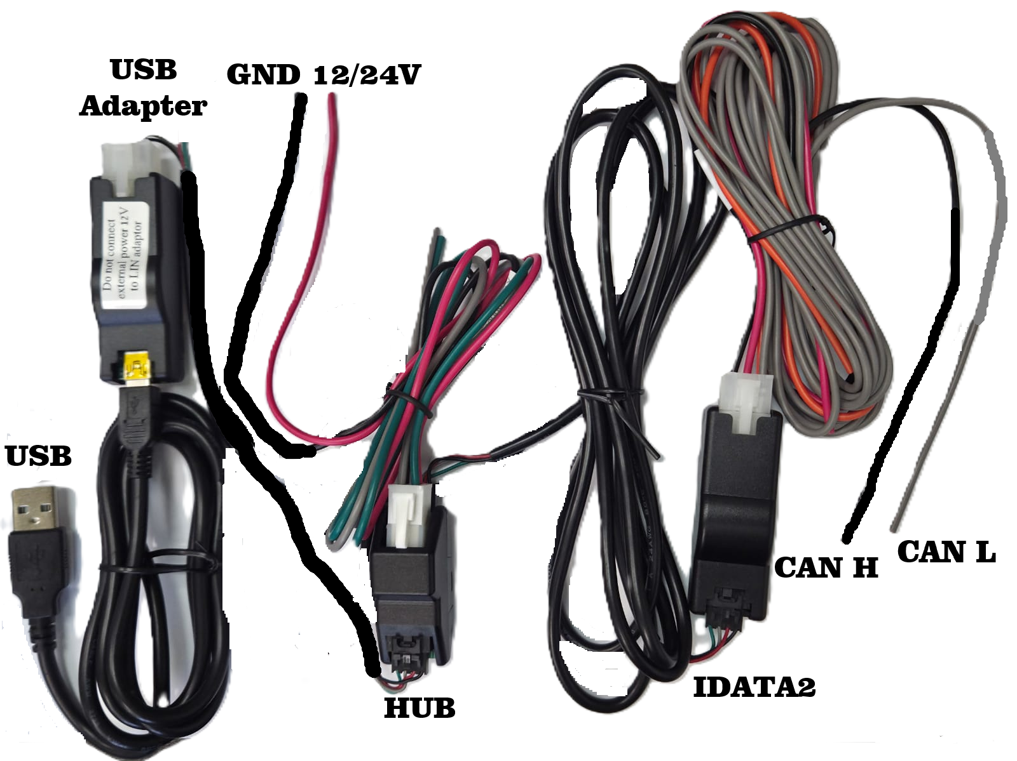
Full Connection Diagram - PC connection for data reading and configuration

11.1.1 Cable Components
- USB Adapter - a USB-to-LIN adapter used to connect the HUB harness to the PC's USB port. A label on the adapter reads "Do not connect external power 12V to LIN adaptor" - this adapter must only ever be powered from the USB connection itself, never from an external 12/24V supply.
- USB - the standard USB-A cable that plugs into the PC.
- GND / 12/24V - the ground (black) and vehicle supply (red) wires that provide power to the HUB harness during bench connection.
- HUB - the central connector block joining the GND/12-24V supply wires, the USB Adapter's LIN wiring, and the IDATA2 harness together.
- IDATA2 - the main device harness connector, carrying power, ground, and communication lines between the HUB and the device itself.
- CAN H / CAN L - the twisted CAN bus signal wires (grey and orange), which carry the CAN High and CAN Low signals to and from the vehicle's CAN bus.

11.1.2 Connection Steps
- Connect the GND (black) and 12/24V (red) wires to a suitable bench power supply, matching the correct polarity, or leave them connected to the vehicle supply if working in-vehicle.
- Connect the HUB harness connector to the corresponding connector on the IDATA2 harness.
- Connect the CAN H and CAN L wires to the vehicle's CAN bus, or to a bench CAN source, observing correct polarity.
- Connect the USB Adapter to the HUB harness, then connect the USB cable from the USB Adapter to a free USB port on the PC.
- Do not connect an external 12/24V supply to the USB (LIN) adapter itself - it must be powered only through the USB connection, as printed on the adapter's label.
- Open the AIS220 Device Monitor application, select the COM port that corresponds to the USB Adapter, and click Connect... as described in Section 2.1.
Note: This wiring configuration is intended for configuration and data-reading purposes only. For permanent installation in the vehicle, use the Installation Connection Diagram described in Section 11.2.

11.2 Vehicle Installation - Installation Connection Diagram
Use this wiring configuration for the permanent installation of the AIS-220 device in the vehicle. Unlike the PC connection described in Section 11.1, this configuration connects the device directly to the vehicle's power, ignition, and CAN bus wiring, without the USB Adapter or bench supply wires.
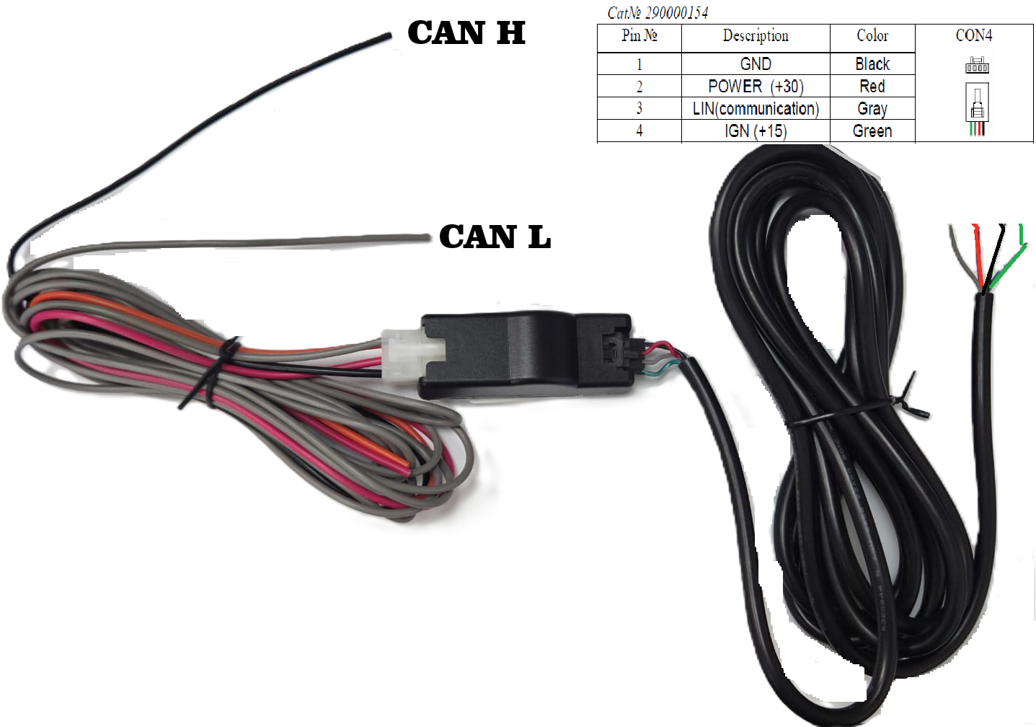
Installation Connection Diagram - in-vehicle installation

11.2.1 CON4 Connector Pinout
The 4-pin CON4 connector (Cat No. 290000154) carries power, ground, ignition, and LIN communication to the device, as detailed below.
Pin No. | Description | Color
1 | GND | Black
2 | POWER (+30) | Red
3 | LIN (communication) | Gray
4 | IGN (+15) | Green

11.2.2 CAN Bus Wires
- CAN H - connect to the vehicle's CAN High line.
- CAN L - connect to the vehicle's CAN Low line.
Note: Correct identification of CAN H and CAN L, and correct polarity of GND and POWER (+30), are essential - reversed or incorrect wiring will prevent the device from communicating on the CAN bus, or from powering up correctly.

11.2.3 Installation Steps
- Identify a suitable, protected mounting location for the device within the vehicle, away from heat sources, moving parts, and exposed water ingress points.
- Connect Pin 1 (GND, black) to a reliable vehicle chassis/ground point.
- Connect Pin 2 (POWER +30, red) to a permanent, fused 12/24V vehicle supply that is live at all times, independent of the ignition switch.
- Connect Pin 3 (LIN, gray) only if the vehicle/device configuration requires LIN communication; otherwise this wire may be left unconnected and insulated.
- Connect Pin 4 (IGN +15, green) to a vehicle supply that is live only when the ignition is switched on.
- Connect the CAN H and CAN L wires to the vehicle's CAN bus at a suitable tap point, matching the polarity described above.
- Secure all wiring with cable ties, route it away from moving or hot components, and insulate any unused wires.
- Once wiring is complete, connect to the device using the Full Connection Diagram procedure described in Section 11.1, if configuration or verification is required, then verify correct operation using the Parameters tab (Section 3) and, if desired, a short Periodic Report Interval (Section 4.1) to confirm the CAN Engine Parameters are decoding correctly before leaving the vehicle.
Note: Remember to return the Periodic Report Interval settings (Section 4.1) to 0 once installation and verification are complete, since these are debug aids only and are not intended to remain active during normal vehicle operation.

